Portsmouth Acheivement Awards
The following award system is available to all Neath Archers Members during our indoor season. There are 4 different disciplines and 5 levels of achievement for each of them.
You will need to achieve 3 recorded scores per category to be eligible for that specific award.
The table below shows the minimum scores that are needed for each classification in a Portsmouth round. The scores are applicable to archers of all ages.

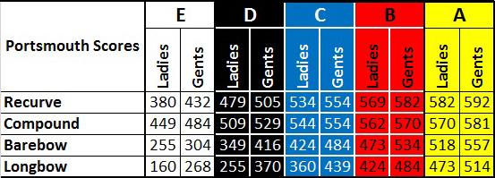

Badges and certificates that are achieved by juniors will be provided free of charge from the club.
There is a small fee for adults who want to claim badges and certificates.
Badge & Certificate = £2.50.
Payment is required upon submission of 3 scores for your relevant achievement and everyone’s orders will be placed on a monthly basis.
For any further information please see :-
Nigel George
( Junior Representative )
